**Activity: Creating an accessible report**

**Introduction**

So far, in the *Designing an accessible report* lesson, you explored the importance of accessibility in reporting and designing accessible reports in Microsoft Power BI. You'll now apply the knowledge you've gained to create an accessible report. In this activity, you will improve the accessibility of an existing Adventure Works sales report using formatting, themes, and design best practices as follows:

* Enhance the accessibility of the visuals using descriptive titles, markers, alt text, and accessible coloring.
* Improve the accessibility of the overall report by changing the tab order and using themes.
* Discuss the improvements made to the report, outlining their benefit for users with disabilities.

**Case study**

Adventure Works recently welcomed new members to its sales team, including Logan, who is visually impaired. Committed to inclusivity, the directors have asked the data analytics team to ensure all reports are accessible, aiming to make them more user-friendly for a wider audience. You are assigned the task of incorporating accessibility features to enhance and refine an existing report that contains sales data for the months of February, March, and April across various sales regions, aligning with the best practices you have learned.

**Instructions**

**Step 1: Open the given report file using Power BI Desktop**

Download and open the *Creating an accessible report* file in Power BI Desktop.

[Creating an accessible report](https://d3c33hcgiwev3.cloudfront.net/FNIAKC4ZSpCh8Ze3tyZHOg_2313ff2a272343449070d9e178fc84e1_Creating-an-accessible-report.pbix?Expires=1711324800&Signature=FwkTl8yM-wHOj8gMXzY1Bd5z-AMi5HWIgoq4hBzue3BsmN1lRTlbLez6AX4Fr8SGhjdeLWVtytL-GkE5U8L0U1NZH8lbDY7DtUbYyQyYRQ80oQR5QcO8lo5zuHPvzd-~9f7gfkbLr2FqFUzb0lGREiuJfLzHkeytfMVMtzjrb9M_&Key-Pair-Id=APKAJLTNE6QMUY6HBC5A" \t "_blank)

[PBIX File](https://d3c33hcgiwev3.cloudfront.net/FNIAKC4ZSpCh8Ze3tyZHOg_2313ff2a272343449070d9e178fc84e1_Creating-an-accessible-report.pbix?Expires=1711324800&Signature=FwkTl8yM-wHOj8gMXzY1Bd5z-AMi5HWIgoq4hBzue3BsmN1lRTlbLez6AX4Fr8SGhjdeLWVtytL-GkE5U8L0U1NZH8lbDY7DtUbYyQyYRQ80oQR5QcO8lo5zuHPvzd-~9f7gfkbLr2FqFUzb0lGREiuJfLzHkeytfMVMtzjrb9M_&Key-Pair-Id=APKAJLTNE6QMUY6HBC5A" \t "_blank)

This step gives you access to the current structure and contents of the report, enabling you to determine where necessary improvements to accessibility need to be made.

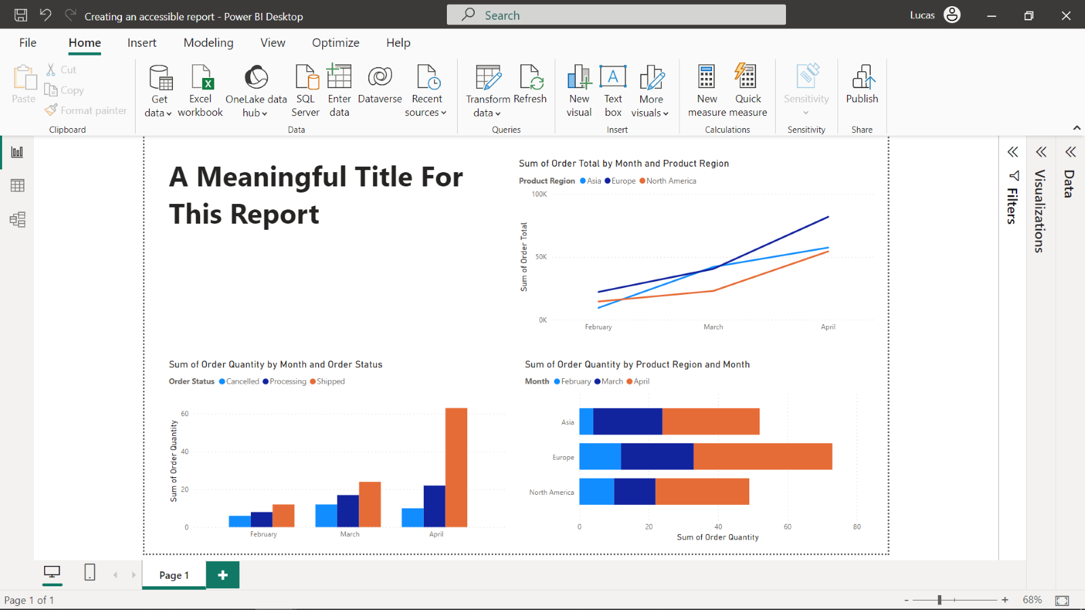

**Step 2: Add a meaningful report title**

To set a clear context for the report's focus, you should provide a succinct and meaningful title. This title will aid all users, including users with disabilities, in quickly grasping the purpose and content of the report.

1. To add a title, select the title of the report.
2. Update it to **Adventure Works Quarterly Regional Sales Report**.

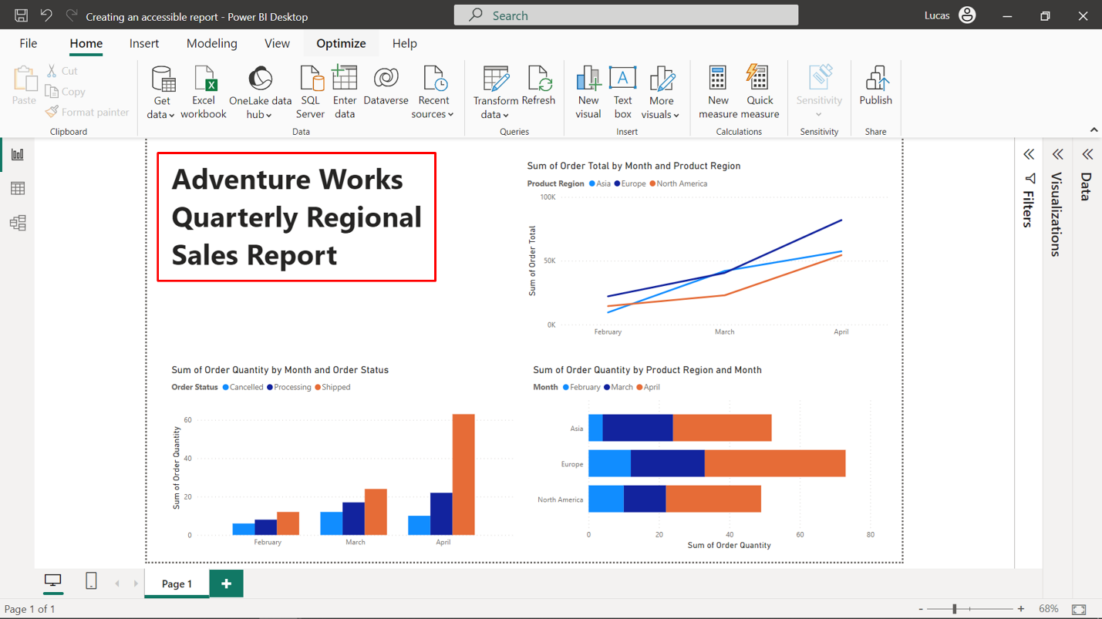

**Step 3: Improve the accessibility of the chart visuals**

**Adjust the chart titles**

The visuals should have existing chart titles as displayed in the screenshot below.

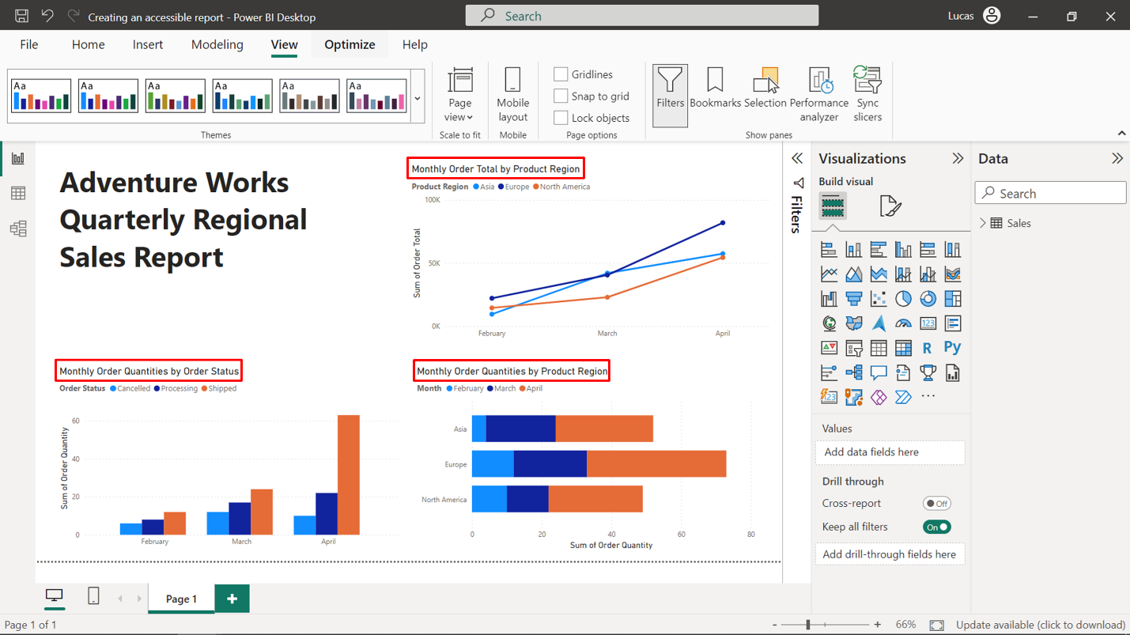

Improve the titles by completing the steps that follow:

1. Select the clustered column chart at the bottom left position of the report, open the **Format** tab, select **General**, and expand **Title**. Change the title to: **Monthly Order Quantities by Order Status**.
2. Repeat step one for the line chart visual at the top right position of the report. Change the title to: **Monthly Order Total by Product Region**.
3. Repeat step one for the stacked bar chart at the bottom right position of the report. Change the title to: **Monthly Order Quantities by Product Region**.

**Display markers in the line chart**

1. Select the line chart visual at the top right position and press the Focus mode button to look closely at the visual. Then, open the **Format** tab, scroll to the **Markers** toggle, and turn it to **On**.
2. To make the report more accessible, a different marker should be used in each region line. To achieve this, expand the **Markers** settings and select a specific region as a series in the **Apply settings to** section. Change the marker symbol to a different shape. Then, repeat the process to modify the marker shape for the other two regions.
3. Now all three regions are represented using a different marker shape as highlighted in the image below.

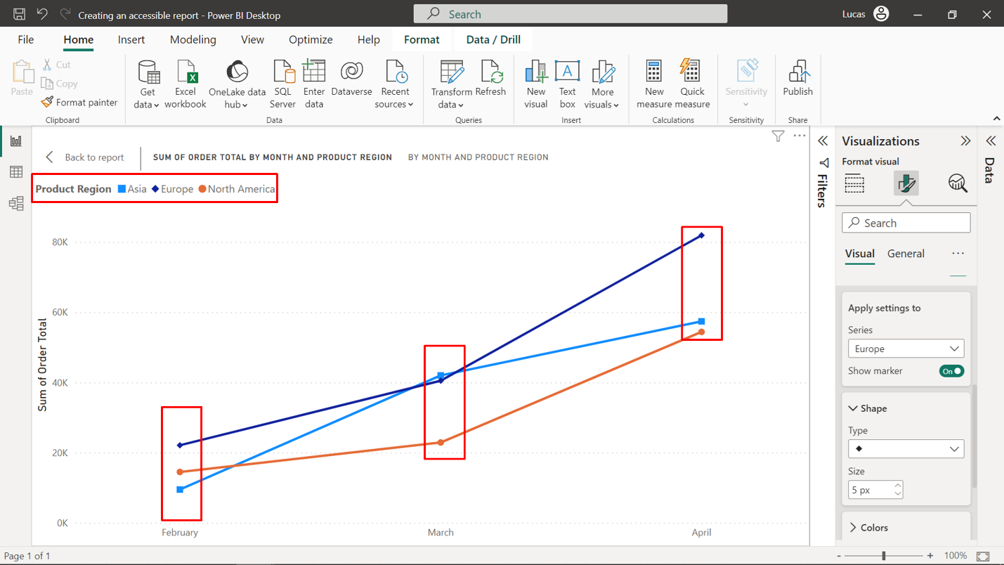

1. Press **Back** to **report** to exit **Focus mode** and return to the main report view.

**Add alt text**

1. Select the clustered column visual at the bottom left position of the report, open the **Format** tab, select **General** and expand **Alt text**. Set the alt text as: From February to April, the canceled order status is consistently the lowest category, processing shows steady growth, and shipped displays exponential growth, notably surging in April.
2. Select the line chart visual at the top right position of the report, open the **Format** tab, select **General**, and expand **Alt text**. Set the alt text as: Order totals increased monthly in all regions with Europe leading. North America and Europe accelerated monthly, particularly in April. Asia’s growth slowed from March to April and totals were comparable to North America except in March when Asia overtook.
3. Select the stacked bar visual at the bottom right position of the report, open the **Format** tab, select **General**, and expand **Alt text**. Set the alt text as: Total order quantities increased monthly for all regions. Europe led each month, showing accelerating growth. Asia had more accelerated growth from February to March than March to April. North America showed the opposite trend.

**Use an accessible theme**

1. Adjust the default color palette used in all visualizations by selecting a theme. To set the theme, open the **Themes** dropdown menu in the **View** ribbon.
2. Select any theme from the **Accessible themes** category highlighted in the screenshot below, such as the second theme **Accessible City park**.

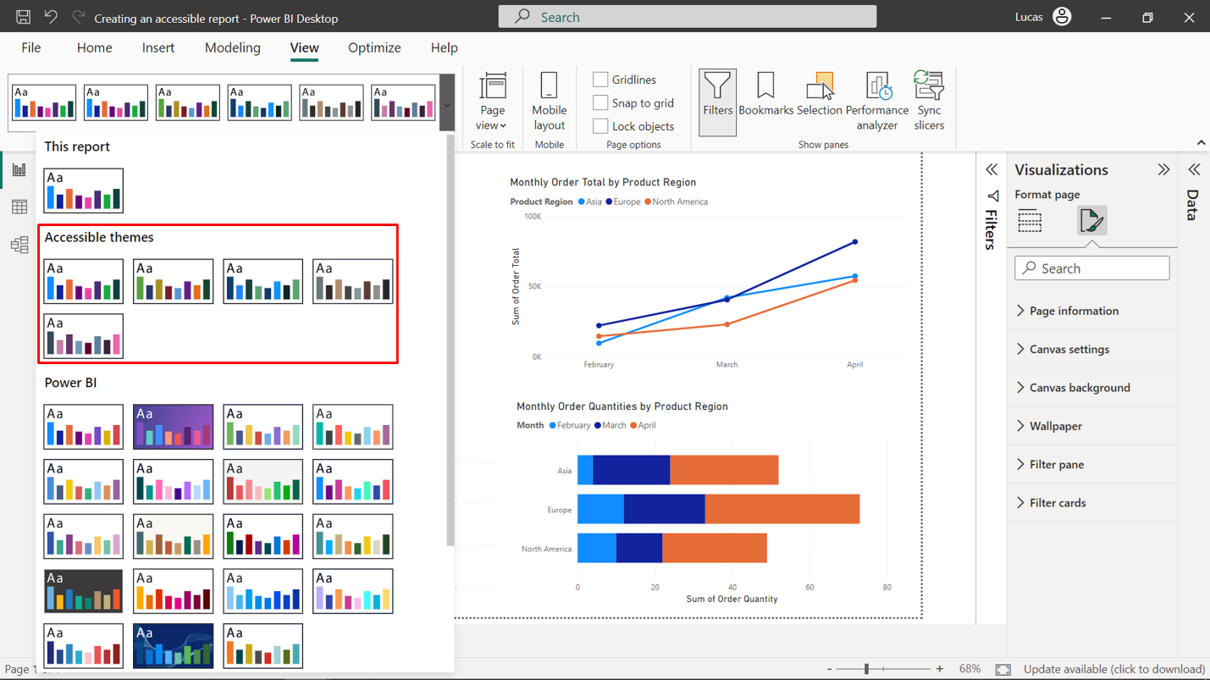

1. The theme applies instantly to all of the visuals in your report, as shown in the screenshot that follows.

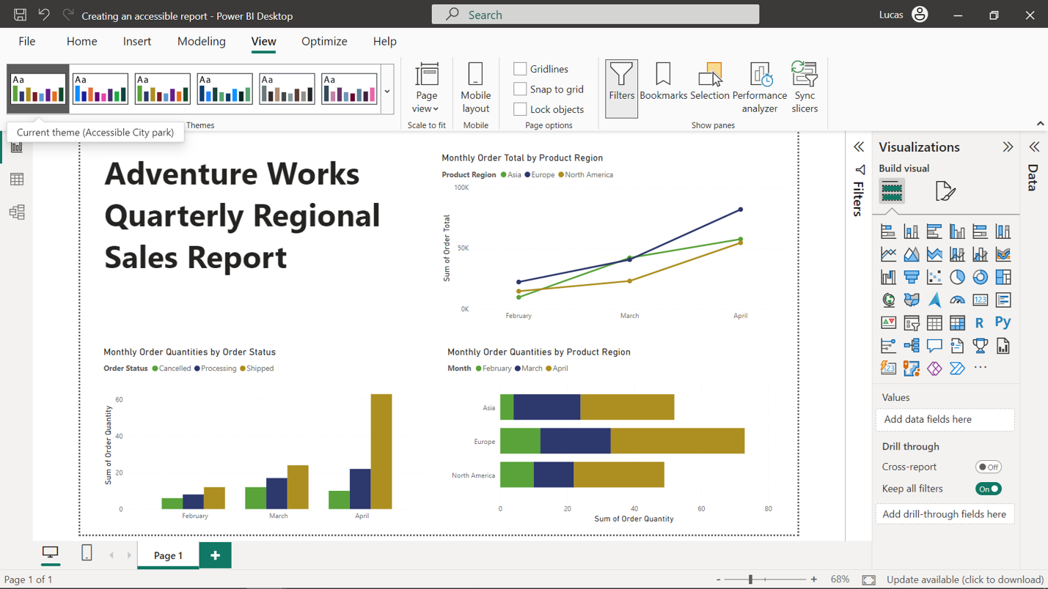

**Note:** You can also change the color of each item in the chart to a single color, using various shades (light color to dark color). To do so, start by selecting each visual one by one. To find the color formatting options, navigate to the **Format** tab, and expand the appropriate section based on the chart type, such as **Lines** for the line chart, **Columns** for the clustered column chart, or **Bars** for the stacked bar chart.

**Step 4: Enhance accessibility of chart navigation by changing tab order**

1. To set the tab order, select the **View** tab in the ribbon. Under **Show panes**, select **Selection** to display the **Selection** pane.
2. Drag and change the position of visuals in the following order on the **Selection** pane, as highlighted in the screenshot below:

* **Text box**
* **Monthly Order Total by Product Region**
* **Monthly Order Quantities by Order Status**
* **Monthly Order Quantities by Product Region**

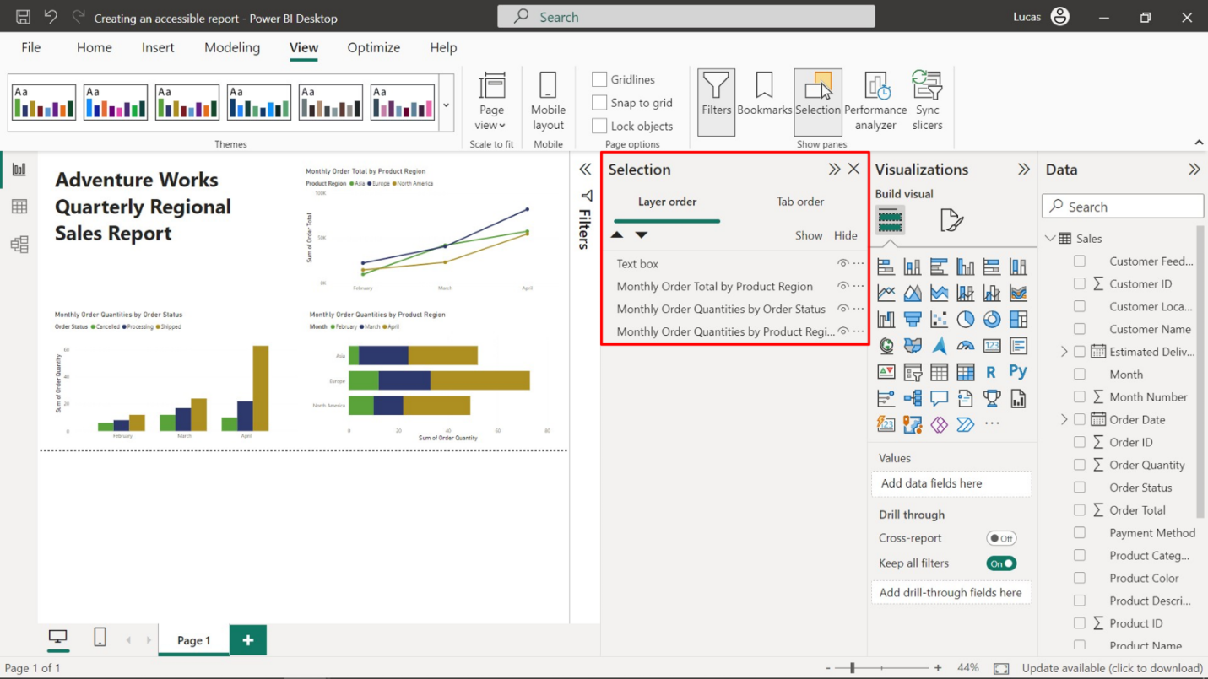

**Step 5: Save the report**

Once you have made all the necessary changes, save the report by opening **File** menu and selecting **Save**. Your final report may appear as follows:

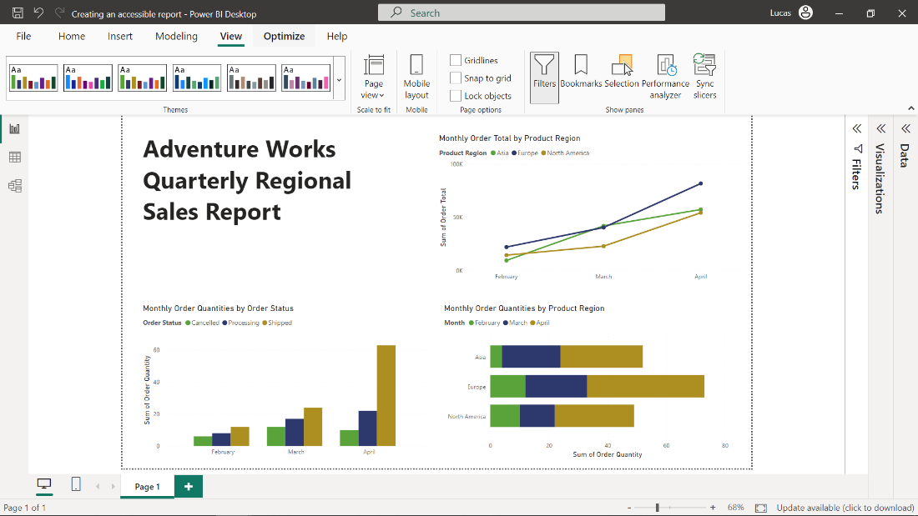

**Step 6: Write a summary of the improvements you made to enhance report accessibility**

The following improvements were made to enhance the accessibility of the Power BI report, with a focus on improving the experience for visually impaired users such as Logan:

* **Descriptive titles**: The titles of the report and each chart were made more descriptive. This enables all users can quickly and easily grasp the report's purpose and the content of each chart.
* **Alt text**: Alternative text descriptions were provided for each chart visual, aligning with inclusive design best practices. This allows users with visual impairments to understand the visualized data, for example, via screen readers. The alt text can also support all users in understanding the purpose and key insights of each chart.
* **Markers**: Markers were added to the line chart. This enhances the accessibility of the visual by providing users with an alternative way to distinguish between data points that is not solely reliant on color.
* **Shaded colors**: Shaded colors were introduced to enhance color contrast within the charts. This helps visually impaired users distinguish between different chart elements more easily.
* **Tab order**: Tab orders for these visuals were changed in the report. This allows users to easily navigate between different elements and sections of the report using their keyboard, which is particularly useful for users with motor difficulties, such as challenges with using a mouse.
* **Accessible theme**: An accessible theme was implemented, designed with features like large, legible fonts and a high-contrast color palette. These features improve the readability and overall accessibility of the report.

These improvements make the report more accessible and create an inclusive environment where all users, regardless of their abilities, can understand and interact effectively with the data.

**Conclusion**

By completing this activity, you explored how to create an accessible report using formatting, themes and design best practices. As you continue on your data analysis journey, remember that accessibility is an integral part of the report design process. By designing for accessibility, you consider a diverse audience, making your reports more inclusive and promoting equity. And that’s not all—these accessibility enhancements also improve the overall user experience and clarity of your reports, which is of benefit to all users.